AN EFFICIENT VLSI DESIGN OF HIGH-SPEED COUNTER WITH STATE EXTENSION LFSR

ABSTRACT
This paper presents a groundbreaking Hybrid Linear Feedback Shift Register (LFSR) design for high-speed counters, integrating traditional LFSR architecture with XOR logic to enhance efficiency and performance. By incorporating a state extension mechanism, the proposed architecture extends the counter's capacity to handle larger counting ranges while maintaining high throughput. Leveraging Verilog HDL for design and implementation ensures compatibility for hardware description and synthesis, with validation conducted through simulation using Model Sim and synthesis using Xilinx tools. This innovative approach offers a promising solution for high-speed counting applications with extended range requirements, representing a significant advancement in VLSI design and digital integration methodologies. The innovative fusion of LFSR and XOR logic in our Hybrid LFSR design offers a promising solution for high-speed counting applications with extended range requirements. By harnessing the combined strengths of these two elements, we achieve unprecedented levels of efficiency and versatility, paving the way for enhanced performance in diverse real-world applications.

TABLE OF CONTENTS

CHAPTER NO. | TITLE | PAGE NO.
 | ABSTRACT
1. | INTRODUCTION  - GENERAL  - OBJECTIVE  - EXISTING SYSTEM  1.4 LITERATURE SURVEY  1.5 PROPOSED SYSTEM
2. | AN EFFICIENT VLSI DESIGN OF HIGH-SPEED COUNTER WITH STATE EXTENSION LFSR  2.1 GENERAL  2.2 MODULES NAME  2.3 MODULE EXPLANATION
3. | BUILT-IN-SELF-TEST  3.1 GENERAL
4. | HARDWARE REQUIRMENTS  4.1 GENERAL  4.1.1 VLSI & SYSTEMS  4.1.2FIELD-PROGRAMMABLE GATE ARRAY  (FPGA)  4.1.3 APPLICATION-SPECIFIC INTEGRATED  CIRCUIT (ASIC)
5. | SOFTWARE REQUIRMENTS  5.1 INTRODUCTION TO MODELSIM  5.2 INTRODUCTION TO XILINX
6. | SIMULATION IMPLEMENTATION  6.1 INTRODUCTION TO HDL  6.2 VERILOG  6.3 CODE IMPLEMENTATION
7. | SNAPSHOTS  7.1 GENERAL  7.2 VARIOUS SNAP SHOTS  7.2 VARIOUS SNAPSHOTS
8. | CHAPTER 8  8.1 SYNTHESIS REPORT  8.2DEVICE UTILIZATION SUMMARY  8.3 AREA COMPARISON  8.4 RTL SCHEMATIC  8.5 TECHNOLOGY DIAGRAM  8.5 TECHNOLOGY DIAGRAM
9. | CONCLUSION AND REFERENCES  9.1 CONCLUSION  9.2 REFERENCES

CHAPTER 1
INTRODUCTION
  - GENERAL

In the vast landscape of modern technology, digital electronics stand as the cornerstone of innovation, driving advancements across industries and transforming the way we interact with the world. At the heart of this digital revolution lies the realm of Very Large-Scale Integration (VLSI) design, where intricate circuits are meticulously crafted to fulfill the demands of ever-evolving applications. Among the myriad of components that populate these digital systems, the humble counter holds a significant place, serving as a fundamental tool for tasks ranging from simple event counting to complex data processing. However, as the pace of technological progress accelerates, the need for counters capable of high-speed operation becomes increasingly apparent, prompting researchers and engineers to explore novel approaches to meet these demands.

This project embarks on a journey into the realm of VLSI design, focusing on the development of a high-speed counter integrated with State Extension Linear Feedback Shift Registers (LFSRs). The integration of State Extension LFSR represents a paradigm shift in counter design, offering not only enhanced speed but also improved scalability, efficiency, and functionality. Through the utilization of cutting-edge tools and methodologies such as Verilog, ModelSim, and Xilinx, this project seeks to push the boundaries of traditional counter architectures, presenting a comprehensive solution tailored to the needs of modern digital applications.

The Evolution of Digital Counters

Counters have long been regarded as indispensable components in digital systems, dating back to the earliest days of computing. From simple ripple counters to more sophisticated synchronous designs, the evolution of counter architectures has been driven by the relentless pursuit of speed, efficiency, and reliability. Traditional counter designs, while effective in their own right, often encounter limitations when confronted with the demands of high-speed operation. As the clock frequencies of modern processors continue to rise, the need for counters capable of keeping pace becomes increasingly pressing, underscoring the importance of innovative design strategies.

The Role of State Extension LFSR

Enter the State Extension Linear Feedback Shift Register (LFSR), a versatile sequential logic circuit renowned for its simplicity, efficiency, and cryptographic strength. LFSRs have found widespread use in various applications, from generating pseudo-random sequences to implementing error detection and correction mechanisms. By extending the state space of the traditional LFSR, State Extension LFSRs offer an attractive solution for enhancing the performance and functionality of digital counters. With their ability to generate longer sequences with improved randomness, State Extension LFSRs provide a valuable tool for applications requiring enhanced security, such as cryptographic algorithms and communication protocols.

Motivation and Objectives

The motivation behind this project stems from the inherent challenges posed by traditional counter designs and the growing demand for high-speed, efficient solutions capable of meeting the requirements of modern digital systems. By integrating State Extension LFSR into the counter architecture, this project seeks to address these challenges head-on, offering a comprehensive solution that combines speed, efficiency, scalability, and functionality. The primary objectives of the project include achieving high-speed operation, enhancing scalability, minimizing power consumption, and providing additional functionality through the integration of State Extension LFSR.

Approach and Methodology

The design process encompasses a systematic approach, beginning with system specification and architectural design, followed by Verilog implementation, simulation, and synthesis. Careful consideration is given to the selection and arrangement of components, optimization of timing constraints, and utilization of advanced synthesis techniques to realize a robust and efficient VLSI design. Through a combination of theoretical analysis, practical experimentation, and iterative refinement, the project aims to achieve its objectives and deliver a cutting-edge solution that pushes the boundaries of traditional counter architectures.

Expected Contributions and Implications

Upon successful completion, this project is expected to make significant contributions to the field of VLSI design by offering insights into innovative counter architectures augmented with State Extension LFSR. The resulting design is anticipated to not only meet the demands of modern digital applications but also pave the way for future advancements in high-speed, efficient circuit design. Moreover, the implications of this research extend beyond the realm of academia, potentially impacting industries such as telecommunications, cryptography, signal processing, and beyond, where high-speed, efficient counters play a critical role in driving innovation and enabling new possibilities in the digital world.

1.2. OBJECTIVE
Develop a high-speed counter architecture capable of efficiently handling large counting ranges. Utilize a Linear Feedback Shift Register (LFSR) as the core component for fast and scalable counting operations. Integrate a novel state extension mechanism within the LFSR to extend the counter's capacity without sacrificing speed. Optimize resource utilization to achieve a balance between performance and hardware complexity. Implement the counter design using Verilog HDL for hardware description and synthesis compatibility. Verify the functionality and performance of the counter through simulation using ModelSim. Perform synthesis using Xilinx tools to generate the hardware configuration for FPGA implementation. Evaluate the effectiveness of the proposed counter architecture in meeting high-speed counting requirements with extended range capabilities.
1.3 PROBLEM STATEMENT
The problem at hand involves the inherent limitations of traditional counter designs in achieving a balance between high-speed operation and extended counting ranges. While counters are crucial components in digital systems, existing architectures often struggle to meet the demands of contemporary applications requiring both rapid counting rates and the ability to handle large counting ranges. Linear Feedback Shift Registers (LFSRs) offer a potential solution due to their simplicity and speed, yet their finite state sizes restrict their counting capacity. Therefore, there is a critical need to develop a novel counter architecture that leverages LFSRs while extending their counting capability, addressing the challenges of traditional designs and meeting the evolving requirements of modern digital systems.

1.3 EXISTING SYSTEM:
In the realm of digital electronics, traditional counter designs have long been the cornerstone of numerous applications, providing essential functionality for tasks such as frequency division, event counting, and sequence generation. However, despite their widespread use and effectiveness, traditional counter architectures are not without their limitations. Understanding the existing system and its drawbacks is crucial for identifying opportunities for improvement and innovation.
Existing System: Traditional Counter Architectures
Traditional counter architectures typically consist of a chain of flip-flops connected in a predetermined sequence, with each flip-flop triggering the next in line upon reaching a certain state. These counters come in various forms, including ripple counters, synchronous counters, and up/down counters, each tailored to specific applications and requirements. While these designs have served as reliable workhorses in digital systems for decades, they exhibit several inherent drawbacks that can hinder their performance and scalability in certain scenarios.
Drawbacks of Traditional Counter Architectures
Limited Speed: One of the primary drawbacks of traditional counter architectures is their limited speed capabilities. As clock frequencies continue to rise in modern digital systems, traditional counters may struggle to keep pace, leading to performance bottlenecks and reduced overall system throughput. The propagation delay inherent in sequential logic circuits can exacerbate this limitation, especially in high-speed applications where every nanosecond counts.
Scalability Challenges: Traditional counter designs often face challenges related to scalability, particularly when it comes to accommodating larger counting ranges or implementing complex functionalities. As the number of bits in the counter increases, so too does the complexity of the design, leading to higher resource utilization, longer propagation delays, and increased power consumption. This lack of scalability can pose significant hurdles in applications requiring flexible and adaptable counting solutions.
Power Consumption: Power efficiency is a critical consideration in modern electronic devices, where energy consumption directly impacts battery life, heat dissipation, and overall system reliability. Traditional counter architectures, characterized by their sequential nature and frequent state transitions, can contribute to significant power consumption, particularly in high-speed applications where clock frequencies are elevated. This drawback becomes especially pronounced in battery-operated devices or energy-constrained environments where power efficiency is paramount.
Limited Functionality: While traditional counters excel at basic counting tasks, they may lack the flexibility and functionality required for more advanced applications. For example, traditional counters may struggle to generate pseudo-random sequences with sufficient randomness for cryptographic operations or fail to provide mechanisms for error detection and correction. As digital systems become increasingly sophisticated, the need for counters capable of supporting diverse functionalities becomes more pronounced.
Susceptibility to Noise and Interference: Sequential logic circuits, including traditional counter architectures, are susceptible to noise, interference, and other forms of signal degradation that can occur in real-world environments. As clock frequencies increase and operating margins shrink, the susceptibility of traditional counters to noise-induced errors and timing violations becomes a significant concern, potentially compromising the reliability and accuracy of digital systems.

1.4 EXISTING SYSTEM TECHNIQUE:
- High-speed counters primarily rely on synchronous counter architectures.
1.5 EXISTING SYSTEM DRAWBACKS:
- Complexed Area More Delay.
- Complex architecture for Testing

CHAPTER 2
LITERATURE SURVEY

2.1 Title: New Programmable LFSR Counters with Automatic Encoding and State Extension
Author: Martin Grymel
Year: 2024
Description:
The picture upgrade techniques are talked about in detail. The strategies proposed in the literary works were arranged into four unique gatherings in light of the procedures. The disadvantages and focal points of the techniques are likewise clarified in detail. This investigation inferred that the Ratio Rule alongside KNN calculation, can deliver promising outcomes contrasted with different techniques. Those manuscripts have experienced the protection procedure. Up to now, those original copies are still in case of harm and less move is made to build up techniques to facilitate the readings. A new method for detecting the end of count for LFSR counters has been proposed. Previous methods for detecting the end of count did not scale with the counter width; thus, they either limited the maximal frequency or, if the detection was spread over several clock cycles, limited the usable counter range. Both issues are solved with the new EOC circuit in conjunction with LFSR sequences. Based on this new EOC detector circuit, it is shown how maximum-length LFSR sequences can be easily extended by a number of states up to one less than the degree of the underlying polynomial. A novel iterative algorithm is proposed to encode a binary sequence value into its corresponding LFSR sequence state. This algorithm is a modification of the conventional iterative algorithm and uses a combination of three LFSRs to avoid the requirement of a binary counter to keep track of the number of shifts. Based on this new algorithm and an existing alternative recursive method, two novel programmable LFSR counter architectures have been proposed, in which each can be configured during runtime with a start count supplied as an ordinary binary value. The counters automatically encode the binary sequence value into the required LFSR state and, once complete, continuously count down from the start value and issue a signal each time the zero state is reached. Alternatively, the counters can be easily modified to decrement with the occurrence of an event rather than in every clock cycle. Applications are, for instance, clock dividers that need to be run at high clock frequencies. The new counter designs are based on the LFSR, which requires the start count to be encoded into a corresponding LFSR state. In the past, different schemes trading off time and memory have been employed to perform a conversion, for instance, offline and then simply supply the converted value to the hardware counter. With the proposed architectures, the conversion can be accomplished by the hardware itself and even at a higher clock frequency than the state-of-the-art counter solution can operate when the counter width is scaled up.

2.2 Title: High-Speed Counter With Novel LFSR State Extension
Author: Hyungjoon Bae; Yujin Hyun; Suchang Kim
Year: 2022
Description:
This paper presents a high-speed counter architecture associated with novel LFSR state extension. By employing the proposed state extension, an m -bit LFSR counter with (2m−1) states is modified to cover 2m states without degrading the counting rate. Based on the property that only the low-order bits are frequently switched, the proposed counter consists of two sub-counters to achieve a high counting rate and reduce the hardware complexity needed to convert an LFSR state into a binary state. The low-order sub-counter is implemented with the proposed LFSR counter, and the high-order sub-counter is designed by employing the conventional synchronous binary counter. In addition, the implemented counter takes into account the speed degradation caused by the large fan-out of the high-order sub-counter. The proposed counter designed with standard cells operates at 2.08 GHz in a 65 nm CMOS technology, and its counting rate is almost independent of the counter size. This paper has proposed a high-speed counter architecture with a novel LFSR state extension method. To reduce the delay caused by detecting an LFSR state in a cycle, such a state is detected by considering only one bit in a cycle, which leads to a diagonal m-bit pattern that can be detected for m cycles. This unique diagonal pattern is detected with m F/Fs and (m−1) gates. Based on a small-sized LFSR counter, the proposed counter is realized by taking a pre-scaled binary counter at the upper bit positions. In other words, the proposed 64-bit counter consists of two sub-counters: a 6-bit LFSR counter at the lower bit positions and a conventional 58-bit binary counter at the upper bit positions. The conventional pre-scaled counter requires a straight ring counter to ensure that both sub-counters count correctly, while the proposed LFSR counter enables the counting of the high-order sub-counter by detecting a specific state. The novel state extension method makes the proposed m-bit LFSR counter traverse 2m states as fast as the conventional LFSR, and thus the counting rate of the proposed counter is almost independent of the counter size. In a 65 nm CMOS technology, the proposed 64-bit counter operates at 2.08 GHz, which is much faster than the conventional binary counter as well as the multistage LFSR counter.

2.3 Title: Low Power Implementation of Linear Feedback Shift Registers
Author: Jayasanthi M, Kowsalyadevi AK
Year: 2019
Description:
This paper describes low power design and implementation of Linear Feedback Shift Register (LFSR). The easiness in implementation and simple operation of Linear Feedback Shift Register have made it fit into a wide range of digital systems design. Since random pattern generation, data encryption and decryption play a major role in communication systems, the LFSR comes into view for developing the patterns for these applications. As the need increases day after day, simple and high-performance design of LFSR is required. As power consumption of the device being an important factor in the VLSI circuits, it has to be reduced by including power optimization techniques in the designs. Pulsed Latch is a popular technique of reducing power consumption which uses Pulsed Latches instead of flip-flops. As latches have lesser number of circuit elements compared to flip-flops, the area is also minimized. By implementing this pulsed latch technique, the linear feedback shift register can be designed with low power and area. The design entry is done in VHDL code and implemented using Cadence tool. In Cadence, Nclaunch, RTL Complier and Encounter tools are used for simulation, synthesis and implementation. With this method, the power reduction is achieved up to 41.99%. This work provides new low power architecture for Linear Feedback Shift Register. The proposed architecture replaces the D flip-flop which is activated by clock with pulsed D latches. The power consumption and delay of the circuit got reduced because of the use of pulsed latches. This pattern generation by LFSR can also be used in data encryption circuits to provide security for generation of binary sequence. It is also used in retrieving the data after recombination and reception. This proposed LFSR may be extended for Data security and direct sequence spread spectrum applications.

2.4 Title: Multistage Linear Feedback Shift Register Counters With Reduced Decoding Logic in 130-nm CMOS for Large-Scale Array Applications
Author: Daniel Morrison; Dennis Delic; Mehmet Rasit Yuce; Jean-Michel Redouté
Year: 2018
Description:
Linear-feedback shift register (LFSR) counters have been shown to be well suited to applications requiring large arrays of counters and can improve the area and performance compared with conventional binary counters. However, significant logic is required to decode the count order into binary, causing system-on-chip designs to be unfeasible. This paper presents a counter design based on multiple LFSR stages that retains the advantages of a single-stage LFSR but only requires decoding logic that scales logarithmically with the number of stages rather than exponentially with the number of bits as required by other methods. A four-stage four-bit LFSR proof of concept was fabricated in 130-nm CMOS and was characterized in a time-to-digital converter application at 800 MHz. This paper presents a generalized design and a practical implementation in 130-nm CMOS of multistage LFSR counters as well as the decoding logic required to convert the count sequence into binary order. The proposed counter is composed of multiple smaller LFSR stages that are triggered by a specific state transition of the previous stage. This configuration allows the decoding logic to be based on a constant sized LUT for any number of stages, rather than requiring the LUT to scale with the size of the counter. The decoding logic of the proposed counter scales proportionally to the logarithm of the number of stages, rather than exponentially with the number of bits as required by decoding methods for conventional LFSRs. The multistage LFSR counter retains many of the same advantages that LFSR counters possess, such as high performance independent of the number of bits in the counter at the tradeoff of a small amount of extra logic.

2.5 Title: A Hardware-Friendly Approach Towards Sparse Neural Networks Based on LFSR-Generated Pseudo-Random Sequences
Author: Foroozan Karimzadeh; Ningyuan Cao; Brian Crafton; Justin Romberg
Year: 2020
Description:
The increase in the number of edge devices has led to the emergence of edge computing where the computations are performed on the device. In recent years, deep neural networks (DNNs) have become the state-of-the-art method in a broad range of applications, from image recognition, to cognitive tasks to control. However, neural network models are typically large and computationally expensive and therefore not deployable on power and memory constrained edge devices. Sparsification techniques have been proposed to reduce the memory foot-print of neural network models. However, they typically lead to substantial hardware and memory overhead. In this article, we propose a hardware-aware pruning method using linear feedback shift register (LFSRs) to generate the locations of non-zero weights in real-time during inference. We call this LFSR-generated pseudorandom sequence based sparsity (LGPS) technique. We explore two different architectures for our hardware-friendly LGPS technique, based on (1) row/column indexing with LFSRs and (2) column-wise indexing with nested LFSRs, respectively. Using the proposed method, we present a total saving of energy and area up to 37.47% and 49.93% respectively and speed up of 1.53× w.r.t the baseline pruning method, for the VGG-16 network on down-sampled ImageNet.

2.6 Title: High-Speed Counter With Novel LFSR State Extension
Author: Hyungjoon Bae , Yujin Hyun , Member, IEEE, Suchang Kim
Year: 2023
Description:
This paper presents a high-speed counter architecture associated with novel LFSR state extension. By employing the proposed state extension, an m-bit LFSR counter with ð2m 1Þ states is modified to cover 2m states without degrading the counting rate. Based on the property that only the low-order bits are frequently switched, the proposed counter consists of two sub-counters to achieve a high counting rate and reduce the hardware complexity needed to convert an LFSR state into a binary state. The low-order sub-counter is implemented with the proposed LFSR counter, and the high-order sub-counter is designed by employing the conventional synchronous binary counter. In addition, the implemented counter takes into account the speed degradation caused by the large fan-out of the highorder sub-counter. The proposed counter designed with standard cells operates at 2.08 GHz in a 65 nm CMOS technology, and its counting rate is almost independent of the counter size. This paper has proposed a high-speed counter architecture with a novel LFSR state extension method. To reduce the delay caused by detecting an LFSR state in a cycle, such a state is detected by considering only one bit in a cycle, which leads to a diagonal m-bit pattern that can be detected for m cycles. This unique diagonal pattern is detected with m F/Fs and ðm 1Þ gates. Based on a small-sized LFSR counter, the proposed counter is realized by taking a prescaled binary counter at the upper bit positions. In other words, the proposed 64-bit counter consists of two sub-counters: a 6-bit LFSR counter at the lower bit positions and a conventional 58-bit binary counter at the upper bit positions. The conventional prescaled counter requires a straight ring counter to ensure that both sub-counters count correctly, while the proposed LFSR counter enables the counting of the high-order sub-counter by detecting a specific state. The novel state extension method makes the proposed m-bit LFSR counter traverse 2m states as fast as the conventional LFSR, and thus the counting rate of the proposed counter is almost independent of the counter size. In a 65 nm CMOS technology, the proposed 64-bit counter operates at 2.08 GHz, which is much faster than the conventional binary counter as well as the multistage LFSR counter.

2.7 Title: Programmable Feedback Shift Register
Author: Saleh Abdel-Hafeez
Year: 2023
Description:
Conventionally, a linear feedback shift register (LFSR) constitutes linear sets of sequences with predictable periods, which are considered vulnerable to intruders. Besides, an LFSR limits the sequences of scan-for-test patterns. This work introduces a private key, which is a collection of keywords, to program the feedback coefficients and initial states of the LFSR, where each keyword modulates the LFSR with a different polynomial of the same degree. That is, each polynomial generates a linear set of sequences. Consequently, the aggregate polynomial has a set of unpredictable and nonlinear sequences with high statistical randomness. The keyword, which holds the coefficients and initial states of the LFSR, can be managed in a few bits and stored in first-in first-out memory array. HSPICE simulations for 90 nm CMOS technology verify the functionality and speed of the proposed programmable feedback shift register (PFSR) of size 16-bit with 64 keywords. Results show a clock speed of 500 MHz with a power consumption of 73 µW and transistor count of 37,593, wherein the overall period has 4,194,240 unpredictable nonlinear sequences that surpass most LFSR structures. The PFSR can be suited for ASIC and reconfigurable HDL synthesis for efficient stream cipher and scan-for-test applications.

2.8 Title: Design And Implementation of Synchronous Binary Counter with Variable Clock for Real Time Applications
Author: Saniya Sharmain, Renuka. B. J
Year: 2022
Description:
In this work, a new fast structure for synchronous binary counting, which has a minimal counting period for practical counters. In many applications, a synchronous binary counter is necessary to be quick and handle a wide bit-width. However, most of the previous counters are associated with a limited counting rate due to large fan-outs and long carry chains, especially when the counter size is not small. In this paper, we first adopt a 1-bit Johnson counter to reduce the overall hardware complexity, and then duplicate the 1-bit Johnson counter to decrease the propagation delay caused by large fan-outs. Implementation results show that the proposed design can be realized with a small number of flip-flops, which is almost linear to the counter size thereby neglecting minimum delays and considering only the maximum delay path of the sub counters implemented in the proposed design. The effectiveness of the proposed method is synthesized and simulated using Xilinx ISE14.7.

2.9 Title: Hardware Efficient Hybrid Pseudo-Random Bit Generator Using Coupled-LCG and Multistage LFSR with Clock Gating Network
Author: Mangal Deep Gupta R. K. Chauhan , and Sandeep Gulia
Year: 2023
Description:
A new method for the generation of pseudo-random bits, based on a coupled-linear congruential generator (CLCG) and two multistage variable seeds linear feedback shift registers (LFSRs) is presented. The proposed algorithm dynamically changes the value of the seeds of each linear congruential generator (LCG) by utilizing the multistage variable seeds LFSR. The proposed approach exhibits several advantages over the pseudo-random bit generator (PRBG) methods presented in the literature. It provides low hardware complexity and high-security strength while maintaining the minimum critical path delay. Moreover, this design generates the maximum length of pseudo-random bit sequence with uniform clock latency. Furthermore, to improve the critical path delay, one more architecture of PRBG is proposed in this work. It is based on the combination of coupled modified-LCG with two variable seeds multistage LFSRs. The modified LCG block is designed by the two-operand modulo adder and XOR gate, rather than the three-operands modulo adder and shifting operation, while it maintains the same security strength. The clock gating network (CGN) is also used in this work to minimize the dynamic power dissipation of the overall PRBG architecture. The proposed architectures are implemented using Verilog HDL and further prototyped on commercially available field-programmable gate array (FPGA) devices Virtex-5 and Virtex-7. The realization of the proposed architecture in this FPGA device accomplishes an improved speed of PRBG, which consumes low power with high randomness compared to existing techniques. The generated binary sequence from the proposed algorithms has been verified for randomness tests using NIST statistical test suites.

2.10 Title: Performance Enhancement Counter with Minimal Clock Period
Author: Anto Mamman Shane S
Year: 2023
Description:
A synchronous binary counter is a fundamental component in VLSI design which are used commonly. synchronous binary counter is fast and are used in many applications as it supports wide bit-width. Due to large fan-outs and long carry chains many previous counters have low counting rate when the size of the counters is large. A new fast structure has been suggested for synchronous binary counter with a very low delay for counter with size ranging from 8 to 128 bits. To reduce the complexity of hardware a 1-bit Johnson counter has been used and then duplicate it to minimise propagation delay induced by large fan-outs. The suggested design is realised with a small number of flip-flops, using a back carry propagation counter and a counter based on state look ahead logic, which reduces power and delay. A novel synchronous binary counter has been developed to achieve a nearly constant delay for practical-sized counters. This design addresses the issues of large fan-out nodes and unwanted propagation delays. The proposed counter design utilizes backward carry propagation and redundant 1-bit Johnson counters. It achieves efficient functionality with a minimal number of flip-flops, slightly exceeding the counter size. Moreover, the counter is capable of operating at a stable frequency of 2GHz, exhibiting minimal dependence on the counter size. In comparison to existing methods, the proposed counter demonstrates a 25% improvement in performance A novel synchronous binary counter has been developed to achieve a nearly constant delay for practical-sized counters. This design addresses the issues of large fan-out nodes and unwanted propagation delays. The proposed counter design utilizes backward carry propagation and redundant 1-bit Johnson counters. It achieves efficient functionality with a minimal number of flip-flops, slightly Zxceeding the counter size. Moreover, the counter is capable of operating at a stable frequency of 2GHz, exhibiting minimal dependence on the counter size. In comparison to existing methods, the proposed counter demonstrates a 25% improvement in performance.
1.7 PROPOSED SYSTEM:
In the proposed pre-scaled counter architecture, an N-bit counter that generates Q[N1:0] is composed of two sub-counters, m-bit wide CL and (N-m)-bit wide CH. The CL sub-counter is an LFSR associated with the proposed state detection, but the CH sub-counter is realized with a conventional binary counter as it counts only once during the time that CL traverses all 2m states. The m-bit LFSR counter CL generates m-bit states represented in Q[m1:0], and the binary counter CH provides binary states expressed in Q[N1:m]. The proposed counter is compared to the conventional synchronous binary counter and the multistage LFSR counter. The performance is analyzed in terms of the maximum counting rate of single-stage block counters that range from 3 bits to 10 bits, and the maximum counting rate and the hardware complexity of practically sized counters that range from 16 bits to 64 bits. Our proposed system introduces a cutting-edge Hybrid Linear Feedback Shift Register (LFSR) architecture for high-speed counting applications. The system comprises a novel integration of traditional LFSR components with XOR logic, forming a hybrid design optimized for efficiency and performance. At the core of the system lies the Hybrid LFSR, which combines the inherent advantages of LFSR structures with the versatility of XOR logic. This integration enables seamless state extension, empowering the counter to handle larger counting ranges while maintaining exceptional throughput rates.

1.8 PROPOSED SYSTEM BLOCK DIAGRAM:

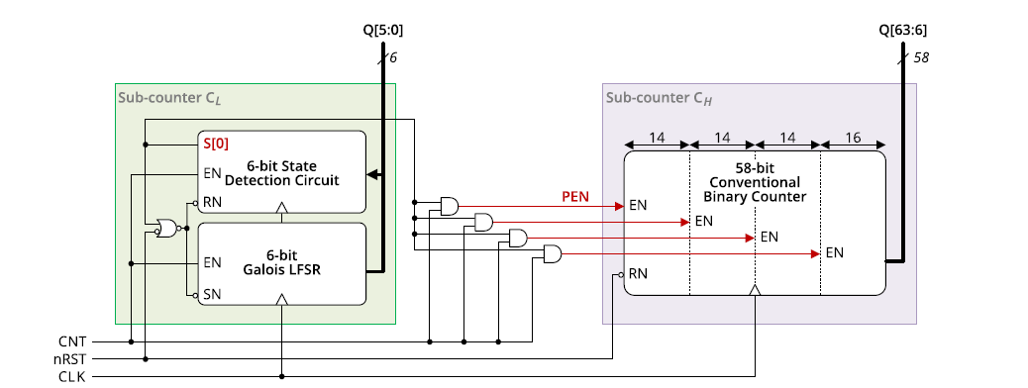

PROPOSED ALGORITHM:
- we present a high-speed counter associated with a novel state extension.
- The proposed counter consists of an LFSR sub-counter and a binary sub-counter, and its delay is almost constant regardless of the counter size.
- The proposed LFSR counter has a state detection circuit to extend the number of states from (2^{m}-1) to 2m without degrading the counting rate for an m-bit LFSR
- Our proposed system introduces a cutting-edge Hybrid Linear Feedback Shift Register (LFSR) architecture for high-speed counting applications. The system comprises a novel integration of traditional LFSR components with XOR logic, forming a hybrid design optimized for efficiency and performance.

PROPOSED SYSTEM ADVANTAGES:
- Better performance in Area.
- Low-energy high-throughput

CHAPTER 2
AN EFFICIENT VLSI DESIGN OF HIGH-SPEED COUNTER WITH STATE EXTENSION LFSR
2.1 GENERAL:
ATPG (acronym for both Automatic Test Pattern Generation and Automatic Test Pattern Generator) is an electronic design automation method/technology used to find an input (or test) sequence that, when applied to a digital circuit, enables automatic test equipment to distinguish between the correct circuit behavior and the faulty circuit behavior caused by defects. The generated patterns are used to test semiconductor devices after manufacture, and in some cases to assist with determining the cause of failure (failure analysis) The effectiveness of ATPG is measured by the amount of modeled defects, or fault models, that are detected and the number of generated patterns. These metrics generally indicate test quality (higher with more fault detections) and test application time (higher with more patterns). ATPG efficiency is another important consideration. It is influenced by the fault model under consideration, the type of circuit under test (full scan, synchronous sequential, or asynchronous sequential), the level of abstraction used to represent the circuit under test (gate, register-transfer, switch), and the required test quality.
A defect is an error caused in a device during the manufacturing process. A fault model is a mathematical description of how a defect alters design behavior. The logic values observed at the device's primary outputs, while applying a test pattern to some device under test (DUT), are called the output of that test pattern. The output of a test pattern, when testing a fault-free device that works exactly as designed, is called the expected output of that test pattern. A fault is said to be detected by a test pattern if the output of that test pattern, when testing a device that has only that one fault, is different than the expected output. The ATPG process for a targeted fault consists of two phases: fault activation and fault propagation. Fault activation establishes a signal value at the fault model site that is opposite of the value produced by the fault model. Fault propagation moves the resulting signal value, or fault effect, forward by sensitizing a path from the fault site to a primary output.
ATPG can fail to find a test for a particular fault in at least two cases. First, the fault may be intrinsically undetectable, such that no patterns exist that can detect that particular fault. The classic example of this is a redundant circuit, designed so that no single fault causes the output to change. In such a circuit, any single fault will be inherently undetectable.
Second, it is possible that a pattern(s) exist, but the algorithm cannot find it. Since the ATPG problem is NP-complete (by reduction from the Boolean satisfiability problem) there will be cases where patterns exist, but ATPG gives up since it will take an incredibly long time to find them.
Fault models:
- Single fault assumption: only one fault occur in a circuit. if we define k possible fault types in our fault model the circuit has n signal lines, by single fault assumption, the total number of single faults is k×n
- Multiple fault assumption: multiple faults may occur in a circuit.
Fault collapsing:
It is possible that Two or more faults, produce same faulty behavior for all input patterns. these faults are called equivalent faults. Any single fault from the set of equivalent faults can represent the whole set. In this case, much less than k×n fault tests are required for a circuit with n signal line. Removing equivalent faults from entire set of faults is called fault collapsing.
The Stuck-at fault model:
In the past several decades, the most popular fault model used in practice is the single stuck-at fault model. In this model, one of the signal lines in a circuit is assumed to be stuck at a fixed logic value, regardless of what inputs are supplied to the circuit. Hence, if a circuit has n signal lines, there are potentially 2n stuck-at faults defined on the circuit, of which some can be viewed as being equivalent to others. The stuck-at fault model is a logical fault model because no delay information is associated with the fault definition. It is also called a permanent fault model because the faulty effect is assumed to be permanent, in contrast to intermittent faults which occur (seemingly) at random and transientfaults which occur sporadically, perhaps depending on operating conditions (e.g. temperature, power supply voltage) or on the data values (high or low voltage states) on surrounding signal lines. The single stuck-at fault model is structural because it is defined based on a structural gate-level circuit model.
A pattern set with 100% stuck-at fault coverage consists of tests to detect every possible stuck-at fault in a circuit. 100% stuck-at fault coverage does not necessarily guarantee high quality, since faults of many other kinds—such as bridging faults, opens faults, and transition (aka delay) faults—often occur.
Transistor faults:
This model is used to describe faults for CMOS logic gates. At transistor level, a transistor maybe stuck-short or stuck-open. In stuck-short, a transistor behaves as it is always conducts (or stuck-on), and stuck-open is when a transistor never conducts current (or stuck-off). Stuck-short will produce a short between VDD and VSS.

Bridging faults:
A short circuit between two signal lines is called bridging faults. Bridging to VDD or Vss is equivalent to stuck at fault model. Traditionally both signals after bridging were modeled with logic AND or OR of both signals. If one driver dominates the other driver in a bridging situation, the dominant driver forces the logic to the other one, in such case a dominant bridging fault is used. To better reflect the reality of CMOS VLSI devices, a Dominant AND or Dominant OR bridging fault model is used. in the latter case, dominant driver keeps its value, while the other one gets the AND or OR value of its own and the dominant driver.

Delay faults:
Delay faults can be classified as:
- Gate delay fault
- Transition fault
- Path delay fault: This fault is due to the sum of all gate propagation delays along a single path. This fault shows that the delay of one or more paths exceeds the clock period. one major problem in finding delay faults is the number of possible paths in a circuit under test (CUT), which in the worst case can grow exponentially with the number of linesn in the circuit.

Combinational ATPG:
The combinational ATPG method allows testing the individual nodes (or flip-flops) of the logic circuit without being concerned with the operation of the overall circuit. During test, a so-called scan-mode is enabled forcing all flip-flops (FFs) to be connected in a simplified fashion, effectively bypassing their interconnections as intended during normal operation. This allows using a relatively simple vector matrix to quickly test all the comprising FFs, as well as to trace failures to specific FFs.
Sequential ATPG:
Sequential-circuit ATPG searches for a sequence of vectors to detect a particular fault through the space of all possible vector sequences. Various search strategies and heuristics have been devised to find a shorter sequence and/or to find a sequence faster. However, according to reported results, no single strategy/heuristic out-performs others for all applications/circuits. This observation implies that a test generator should include a comprehensive set of heuristics.
Even a simple stuck-at fault requires a sequence of vectors for detection in a sequential circuit. Also, due to the presence of memory elements, the controllability and observabilityof the internal signals in a sequential circuit are in general much more difficult than those in a combinational logic circuit. These factors make the complexity of sequential ATPG much higher than that of combinational ATPG, where a scan-chain (i.e. switchable, for-test-only signal chain) is added to allow simple access to the individual nodes.
Due to the high complexity of the sequential ATPG, it remains a challenging task for large, highly sequential circuits that do not incorporate any Design For Testability (DFT) scheme. However, these test generators, combined with low-overhead DFT techniques such as partial scan, have shown a certain degree of success in testing large designs. For designs that are sensitive to area and/or performance overhead, the solution of using sequential-circuit ATPG and partial scan offers an attractive alternative to the popular full-scan solution, which is based on combinational-circuit ATPG.
ATPG and nanometer technologies:
Historically, ATPG has focused on a set of faults derived from a gate-level fault model. As design trends move toward nanometer technology, new manufacture testing problems are emerging. During design validation, engineers can no longer ignore the effects of crosstalk and power supply noise on reliability and performance. Current fault modeling and vector-generation techniques are giving way to new models and techniques that consider timing information during test generation, that are scalable to larger designs, and that can capture extreme design conditions. For nanometer technology, many current design validation problems are becoming manufacturing test problems as well, so new fault-modeling and ATPG techniques will be needed.
Algorithmic methods:
Testing very-large-scale integrated circuits with a high fault coverage is a difficult task because of complexity. Therefore many different ATPG methods have been developed to address combinational and sequential circuits. Early test generation algorithms such as boolean difference and literal proposition were not practical to implement on a computer.
The D Algorithm was the first practical test generation algorithm in terms of memory requirements. The D Algorithm [proposed by Roth 1966] introduced D Notation which continues to be used in most ATPG algorithms. D Algorithm tries to propagate the stuck at fault value denoted by D (for SA0) or D (for SA1) to a primary output. Path-Oriented Decision Making (PODEM) is an improvement over the D Algorithm. PODEM was created in 1981, by Prabhu Gödel, when shortcomings in D Algorithm became evident when design innovations resulted in circuits that D Algorithm could not realize.
Fan-Out Oriented (FAN Algorithm) is an improvement over PODEM. It limits the ATPG search space to reduce computation time and accelerates back tracing. Methods based on Boolean satisfied ability are sometimes used to generate test vectors. Pseudorandom test generation is the simplest method of creating tests. It uses a pseudorandom number generator to generate test vectors, and relies on logic simulation to compute good machine results, and fault simulation to calculate the fault coverage of the generated vectors. Wavelet Automatic Spectral Pattern Generator (WASP) is an improvement over spectral algorithms for sequential ATPG. It uses wavelet heuristics to search space to reduce computation time and accelerate the compactor

2.2 MODULE SEPERATION:
- Parallel Counter Architecture Design
- Pipeline Register Insertion
- Linear Feedback Shift Register (LFSR)
- Pattern count
- Control Logic
- Output Interface

2.3 MODULE DESCRIPTION:
Module 1: Parallel Counter Architecture Design
- Divide the counter into parallel stages, where each stage counts a subset of bits simultaneously.
- Determine the number of parallel stages based on throughput requirements and target clock frequency.
- Implement each parallel stage as a separate module, with inputs and outputs for data propagation between stages.
- Ensure synchronous operation of all stages to maintain consistency in counting.
Module 2: Pipeline Register Insertion
- Identify critical paths in the counter architecture, i.e., paths with the longest propagation delay.
- Insert pipeline registers along these critical paths to break down the computation into smaller stages.
- Determine the optimal placement of pipeline registers to balance timing constraints and minimize clock cycle time.
- Implement each pipeline register as a separate module, inserting them between appropriate stages of the counter architecture.
Module 3: Linear Feedback Shift Register (LFSR):
- Design an LFSR module to generate pseudo-random sequence for state extension.
- Determine the feedback polynomial based on the desired sequence length and properties.
- Implement the LFSR module with shift and feedback logic to generate the sequence.
- Ensure synchronization of LFSR output with the counter operation for proper state extension.
Module 4: Control Logic:
- Design control logic to manage the operation of the counter, including initialization, counting, and state extension.
- Implement control signals for enabling/disabling counting, resetting the counter, and controlling LFSR state extension.
- Ensure proper synchronization and timing of control signals with the counter and LFSR operation.
Module 5: Output Interface
- Design an output interface module to capture and output the counter value.
- Implement necessary logic for latching the counter value and providing it to external circuitry.
- Ensure synchronization of output data with the clock signal to avoid metastability issues.

CHAPTER 3
SOFTWARE REQUIREMENT
- Verification Tool
- Modelsim 6.4c
- Synthesis Tool
- Xilinx ISE 13.2
5.1 MODELSIM
MODELSIM
Modelsim is a powerful simulator that can be used to simulate the behavior and performance of logic circuits. This tutorial gives a rudimentary introduction to functional simulation of circuits, using the graphical waveform editing capability of Modelsim. It discusses only a small subset of Modelsim features. The simulator allows the user to apply inputs to the designed circuit, usually referred to as test vectors, and to observe the outputs generated in response. The user can use the Waveform Editor to represent the input signals as waveforms
Modelsim performs simulation in the context of projects – one project at a time. A project includes the design files that specify the circuit to be simulated. We will first create a directory (folder) to hold the project used in the tutorial. Create a new directory and call it model seminar. Copy the file majority into this directory
Open the Modelsim simulator. In the displayed window select File > New > Project
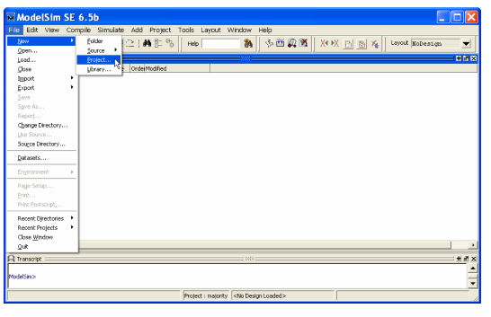
A Create Project pop-up box will appear, as illustrated. Specify the name of the project; we chose the name majority. Use the Browse button in the Project Location box to specify the location of the directory that you created for the project. Modelsim uses a working library to contain the information on the design in progress; in the Default Library Name field we used the name work. Click OK.

Click on Add Existing File and add the file majority.v to the Then close the windows.

At this point, the main Modelsim window will include the file as indicated . Observe that there is a question mark in the Status column. Now, select Compile È Compile All, which leads to the window. indicating in the Transcript window (at the bottom) that the circuit in the majority.v file was successfully compiled. Note that this is also indicated by a check mark in the Status column. The circuit is now ready for simulation.

CREATING WAVEFORMS FOR SIMULATION:

To perform simulation of the designed circuit, it is necessary to enter the simulation mode by selecting simulate > start simulation. Expand the work directory and select the design called majority, as shown in the figure. Then click ok. Now, an objects window appears in the main Modelsim window. it shows the input and output signals of the designed circuit to simulate the circuit we must first specify the values of input signals, which can be done by drawing the input waveforms using the graphical waveform editor. Select view ç wave which will open the wave window depicted .the wave window may appear as a part of the main Modelsim window; in this case undock it by clicking on the dock/undock icon in the top right corner of the window and resize it to a suitable size. if the wave window does not appear after undocking, then select view è wave in the main Modelsim window.
For our simple circuit, we can do a complete simulation by applying all eight possible valuations of the input signals x1, x2 and x3. The output f should then display the logic values defined by the truth table for the majority function. we will first draw the waveform for the x1 input. in the objects window, right-click on x1. Then, choose create wave in the drop-down box that appears,
Modelsim provides different possibilities for creating and editing waveforms. to illustrate another approach, we will specify the waveform for x2 by first creating it to have a 0 value throughout the simulation period, and then editing it to produce the required waveform. repeat the above procedure, by right-clicking on x2 in the objects window, to create a waveform for x2 that has the value 0 in the interval 0 to 800 ns. so far, we used the wave window in the select mode which is indicated by the highlighted icon . now, click on the edit mode icon , and then right-click to reach the drop-down menu shown in figure and select wave edit. note that this causes the toolbar menu to include new icons for use in the editing process.
we will use a third approach to draw the waveform for x3. this signal should alternate between 0 and 1 logic values at each 100-ns interval. such a regular pattern is indicative of a clock signal that is used in many logic circuits. to illustrate how a clock signal can be defined, we will specify x3 in this manner. Right-click on the x3 input in the

SIMULATION:
To perform the simulation, open the Wave window and specify that the simulation should run for 800 ns, as indicated. Then, click on the Run-All icon. The result of the simulation will be displayed as presented. Observe that the output f is equal to 1 whenever two or three inputs have the value 1, which verifies the correctness of our design.
The purpose of this tutorial is to provide a quick introduction to Modelsim, explaining only the rudimentary aspects of functional simulation that can be performed using the Modelsim Graphical User Interface. More details about the Modelsim GUI and its use in simulation can be found in the Generating Stimulus with Waveform Editor chapter of Modelsim SE User’s Manual, which is available as part of an installed Modelsim-SE simulator. A more extensive discussion of simulation using the Modelsim simulator is provided in the tutorial Using Modelsim to Simulate Logic Circuits for Altera Devices, which is available on Altera’s University Program Web site.

ADVANCED CODE COVERAGE
Modelsim advanced code coverage capabilities and ease of use lower the barriers for leveraging this valuable verification resource. The Modelsim advanced code coverage capabilities provide valuable metrics for systematic verification. All coverage information is stored in the Unified Coverage Database (UCDB), which is used to collect and manage all coverage information in a highly efficient database. Coverage utilities that analyze code coverage data, such as merging and test ranking, are available. Coverage results can be viewed interactively, post-simulation, or after a merge of multiple simulation runs. Code coverage metrics can be reported by instance or by design unit, providing flexibility in managing coverage data.
MIXED HDL SIMULATION
Modelsim combines simulation performance and capacity with the code coverage and debugging capabilities required to simulate multiple blocks and systems and attain ASIC gate-level sign-off. Comprehensive support of Verilog, System Verilog for Design, VHDL, and System C provide a solid foundation for single and multi-language design verification environments. Modelsim easy to use and unified debug and simulation environment provide today’s FPGA designers both the advanced capabilities that they are growing to need and the environment that makes their work productive.
EFFECTIVE DEBUG ENVIRONMENT
The Modelsim debug environment’s broad set of intuitive capabilities for Verilog, VHDL, and System C make it the choice for ASIC and FPGA design. Modelsim eases the process of finding design defects with an intelligently engineered debug environment. The Modelsim debug environment efficiently displays design data for analysis and debug of all languages. Modelsim allows many debug and analysis capabilities to be employed post-simulation on saved results, as well as during live simulation runs. For example, the coverage viewer analyzes and annotates source code with code coverage results, including FSM state and transition, statement, expression, branch, and toggle coverage. Signal values can be annotated in the source window and viewed in the waveform viewer, easing debug navigation with hyperlinked navigation between objects and its declaration and between visited files. Race conditions, delta, and event activity can be analyzed in the list and wave windows. User-defined enumeration values can be easily defined for quicker understanding of simulation results. For improved debug productivity, Modelsim also has graphical and textual dataflow capabilities.
Opening Modelsim You can access Modelsim either through the PCs in the lab or an Athena Sun Workstation. On the Lab PC under Windows XP, launch Modelsim from the Desktop icon (or Start > All Programs > Modelsim SE > Modelsim). If it’s your first time opening Modelsim or if you encounter problems with licenses, you can run the license wizard: Start > All Programs > Modelsim SE > Licensing Wizard. The license file should be set to ‘27000@mtlcad.mit.edu’. On Athena Sun workstation, first run 'setup 6.111' to configure your environment correctly. Then run 'vsim &' to start the application. Online help and tutorials for Modelsim are available from the Help pull-down menu. Help > SE PDF Documentation > Tutorial will bring up the guide for a recommended tutorial. The PDF for the user's manual is also available on the course website: Software Tools > Verilog Simulation. (Must have MIT certificates).
GATE LEVEL SIMULATION
Quartus generates a structural description of your design in your simulation folder. It can be used to do a gate level simulation with delay definition. Note that as opposed to RTL simulation, your project can contain bdf files. This is due to the fact that the only file used by Modelsim is the VHDL one generated by Quartos.
The generated vhdl uses some components of altera's libraries. If you use Modelsim-Altera it will works directly, but if you have the original Modelsim software, you will have to import the altera's libraries. See the Quartus documentation for more details.
Compile your project and run the Modelsim Gate-Level Simulation by selecting Tools->EDA Simulation Tool->Run EDA Gate-Level Simulation. In Modelsim we have to load the delay definition file. Select Simulate->Start Simulation..., go in the SDF tab and add the .sdo file generate by Quartus. Go back in the Design tab, expand the work library, select the top level entity or, if you have one, your test bench and click OK.

CREATING FILES IN MODELSIM
There are two ways to start creating your designs in Modelsim: 1.Creating a project or 2.Opening or creating a Verilog file without a project.
1. Creating a project Create a new project: File > New > Project Specify your project name and specify the Project Location as a directory under E:\Documents and Settings\[username]\Desktop. Leave the Default Library Name to work. Now, you have created a project .mpf file and a working library, which can store useful information, such as your simulation configuration, for future use. Now, add items to your project by either creating a new Verilog source file or adding an existing file.
2. Creating without a project: Create a new file: File > New > Source > Verilog or open an existing Verilog file: File > Open > File. To compile the source files in the Modelsim environment, you must create a working directory or map an existing working directory: File > New > Library or File > Import > Library or type ‘vlib work’ in the command line window.
As a good design practice, we recommend you to follow the first option: creating a new project. For Verilog files required for labs and psets, create a new project such as ‘lab01’ or ‘pset03’ under the default work library as its working library, because you do not explicitly need to specify the work library when compiling. For the final project, which contains many layers of hierarchy, create a new project under a new working library, such as ‘final_proj’. For this tutorial, we are using the second option: opening existing files and creating a new working library called sims. If you are not already located in your sims directory, then move into this directory using the Modelsim command line. On the left-hand side of the Modelsim window, you should see a number of resource libraries (vital2000, ieee, etc...): Right-click in this window and select to create a new library, called ‘sims’, or type ‘vlib sims’ in the command line. COMPILING IN MODELSIM
Compile source files: Compile > Compile. You will see that the default library is the work library. Choose to compile your files in the newly created Sims library rather than the work library. To compile your files, browse to your src directory and select the files counter’s, top.v and tbtutorial.v. Double-click the selected files to compile. We will use the other files later in this tutorial. If there is an error in your Verilog code it will be reported at this time with an error message. Your downloaded tutorial files should not contain any errors. 4 You can recompile your files by looking at the ‘library’ pane. On the left-hand side of Modelsim window, choose the ‘library’ tab and click on the square containing plus sign next to sims working library. You should see the three files you compiled earlier under Sims library. Highlight the files you want to recompile, and when you right-click on those files, you can delete, recompile or simulate the highlighted files

Modelsim SE - High Performance Simulation and Debug
Modelsim SE is our UNIX, Linux, and Windows-based simulation and debug environment, combining high performance with the most powerful and intuitive GUI in the industry.
What's New in Modelsim SE?
- Improved FSM debug options including control of basic information, transition table and warning messages. Added support of FSM Multi-state transitions coverage (i.e. coverage for all possible FSM state sequences).
- Improved debugging with hyperlinked navigation between objects and their declaration, and between visited source files.
- The dataflow window can now compute and display all paths from one net to another.
- Enhanced code coverage data management with fine grain control of information in the source window.
- Toggle coverage has been enhanced to support System Verilog types: structures, packed unions, fixed-size multi-dimensional arrays and real.
- Some IEEE VHDL 2008 features are supported including source code encryption. Added support of new VPI types, including packed arrays of struct nets and variables.

Modelsim SE Features:
- Multi-language, high performance simulation engine
- Verilog, VHDL, System Verilog Design
- Code Coverage
- System Verilog for Design
- Integrated debug
- JobSpy Regression Monitor
- Mixed HDL simulation option
- System C Option
- TCL/tk
- Solaris and Linux 32 & 64-bit
- Windows 32-bit
Modelsim SE Benefits:
- High performance HDL simulation solution for FPGA & ASIC design teams
- The best mixed-language environment and performance in the industry
- Intuitive GUI for efficient interactive or post-simulation debug of RTL and gate-level designs
- Merging, ranking and reporting of code coverage for tracking verification progress
- Sign-off support for popular ASIC libraries
- All Modelsim products are 100% standards based. This means your investment is protected, risk is lowered, reuse is enabled, and productivity is enhanced
- Award-winning technical support

High-Performance, Scalable Simulation Environment:
Modelsim provides seamless, scalable performance and capabilities. Through the use of a single compiler and library system for all Modelsim configurations, employing the right Modelsim configuration for project needs is as simple as pointing your environment to the appropriate installation directory.
Modelsim also supports very fast time-tenet-simulation turnarounds while maintaining high performance with its new black box use model, known as bbox. With bbox, non-changing elements can be compiled and optimized once and reused when running a modified version of the testbench. Bbox delivers dramatic throughput improvements of up to 3X when running a large suite of test cases.
Easy-to-Use Simulation Environment:
An intelligently engineered graphical user interface (GUI) efficiently displays design data for analysis and debug. The default configuration of windows and information is designed to meet the needs of most users. However, the flexibility of the Modelsim SE GUI allows users to easily customize it to their preferences. The result is a feature-rich GUI that is easy to use and quickly mastered.
A message viewer enables simulation messages to be logged to the Modelsim results file in addition to the standard transcript file. The GUI’s organizational and filtering capabilities allow design and simulation information to be quickly reduced to focus on areas of interest, such as possible causes of design bugs.
Modelsim SE allows many debug and analysis capabilities to be employed post-simulation on saved results, as well as during live simulation runs. For example, the coverage viewer analyzes and annotates source code with code coverage results, including FSM state and transition, statement, expression, branch, and toggle coverage. Signal values can be annotated in the source window and viewed in the waveform viewer. Race conditions, delta, and event activity can be analyzed in the list and wave windows. User-defined enumeration values can be easily defined for quicker understanding of simulation results. For improved debug productivity, Modelsim also has graphical and textual dataflow capabilities. The memory window identifies memories in the design and accommodates flexible viewing and modification of the memory contents. Powerful search, fill, load, and save functionalities are supported. The memory window allows memories to be pre-loaded with specific or randomly generated values, saving the time-consuming step of initializing sections of the simulation merely to load memories. All functions are available via the command line, so they can be used in scripting.

Advanced Code Coverage
The Modelsim advanced code coverage capabilities deliver high performance with ease of use. Most simulation optimizations remain enabled with code coverage. Code coverage metrics can be reported by-instance or by-design unit, providing flexibility in managing coverage data. All coverage information is now stored in the Unified Coverage DataBase (UCDB), which is used to collect and manage all coverage information in one highly efficient database. Coverage utilities that analyze code coverage data, such as merging and test ranking, are available.
The coverage types supported include:
- Statement coverage: number of statements executed during a run
- Branch coverage: expressions and case statements that affect the control flow of the HDL execution
- Condition coverage: breaks down the condition on a branch into elements that make the result true or false
- Expression coverage: the same as condition coverage, but covers concurrent signal assignments instead of branch decisions
- Focused expression coverage: presents expression coverage data in a manner that accounts for each independent input to the expression in determining coverage results
- Enhanced toggle coverage: in default mode, counts low-to-high and high-to-low transitions; in extended mode, counts transitions to and from X
- Finite State Machine coverage: state and state transition coverage

SYNTHESIS TOOL:
5. 2 XILINX ISE (INTEGRATED SYNTHESIS ENVIRONMENT)
INTRODUCTION
For two-and-a-half decades, Xilinx has been at the forefront of the programmable logic revolution, with the invention and continued migration of FPGA platform technology. During that time, the role of the FPGA has evolved from a vehicle for prototyping and glue-logic to a highly flexible alternative to ASICs and ASSPs for a host of applications and markets. Today, Xilinx® FPGAs have become strategically essential to world-class system companies that are hoping to survive and compete in these times of extreme global economic instability, turning what was once the programmable revolution into the “programmable imperative” for both Xilinx and our customers.
The Xilinx Integrated Software Environment (ISE) is a powerful and complex set of tools. The purpose of this guide is to help new users get started using ISE to compile their designs. This guide provides a very high-level overview of how the tools work, and takes the reader through the process of compiling.
For the past 25 years FPGAs have relentlessly increased in logic cell counts, functionality, and lower cost per transistor. In doing so, FPGAs have steadily taken market share away from the gate array and ASIC markets. Roughly 15 years ago, this FPGA progression helped render gate arrays obsolete. Today, numerous trends – the exorbitant cost of designing and manufacturing ASICs, ever-changing and not-yet-defined standards, the need to reduce Bill of Materials, and the need for both hardware and software programmability, all in the face of rough economic times and reduced staffing – are converging to create an environment where electronics products designers are, at a greater pace, dumping ASICs in favor of FPGAs. I call the convergence of these trends the programmable imperative.
FPGAs are available today with several hundreds of thousands of programmable cells, up to 11.2 Gbps transceivers, 38 Mb of Block RAM, and 2,000 DSP slices. Designers are leveraging these FPGAs to address an ever-growing number of applications. All things considered, the opportunity is ripe for FPGAs to step up the pace in gobbling up more ASIC market share and claim a more central role as the heart of next-generation electronic innovations.
Xilinx is actively moving to seize the opportunity and help customers get their FPGA-based innovations to market quickly. With this goal in mind as we introduced our Virtex-6 and Spartan-6 FPGA families this year, the need for hardware- and software-design tools, IP, development boards, and support was emphasized. Xilinx has always offered these elements in some manner, but now we are making a concerted effort to bring our customers very defined and refined flows closely tied to our silicon, in what we call Targeted Design Platforms.
You can view our Targeted Design Platform approach as a pyramid (see Figure 1). Our Base Platform serves as the foundation layer of the pyramid. It is composed of our Virtex-6 and Spartan-6 FPGA silicon, our ISE Design Suite, and base development boards. The next layer above that is our Domain Specific Platform, in which we offer embedded, DSP, and connectivity IP, domain tools and reference designs, and FMC daughter cards that plug into our base boards. On top of that layer, we offer customers various Market Specific Platforms that are composed of communication, video, or AVB market specific IP, custom tools, and custom boards. If customers choose to use all these platforms for their designs, they can significantly reduce their overall design time and concentrate the majority of their design efforts on the value-added portions of their designs. Customers can, if they want, design every function in their designs from scratch, but most customers will certainly see the benefits of not reinventing the wheel and choose to concentrate on the value-added portions of their designs.

Smorgasbord approach changes
As part of the FPGA Targeted Design Platform approach we are also refining our tool flows to suit specific design disciplines. Traditionally we offered all our users one smorgasbord of tools and left it up to each user to figure out which tools match the tasks. However, we will soon be offering new domain-specific editions of our ISE Design Suite to help users pair tools with specific jobs while obtaining the number of tool licenses suitable to their budgets.
One of these editions, DSP Edition, bundles an improved System Generator for DSP with AccelDSP synthesis, DSP-specific IP running on top of the ISE design environment. The DSP Edition is primarily targeted at algorithm developers who are not HDL designers, but logic designers who do some amount of algorithm development will also find it useful. In addition, the Xilinx Software Development Kit (SDK) is a stand-alone tool, so if DSP Edition users want to do a bit of application software development to go with their algorithms they can add an SDK to the DSP Edition.
The move to a Targeted Design Platform approach makes sense when you consider how the FPGA and ASIC businesses have fared over the last 10 years. Just 10 years ago, roughly 80 percent of Xilinx’s business came from the wired and wireless communications industry. Thus, when the dot-com bubble burst circa 2001, the communications business declined and in turn adversely affected our business along with the rest of the semiconductor industry. To ensure this wouldn’t happen again to Xilinx to the degree it happened then, in 2002 Xilinx quickly created vertical application groups in aerospace and defense, automotive, and Industrial, Scientific, and Medical (ISM), and in broadcast as well as in wired and wireless communications. Since then, these groups have helped Xilinx establish a much broader customer base.
That investment in vertical groups has allowed us to diversify to the point where today wired and wireless communications only accounts for 44 percent of our business, while the balance is spread between ISM, A&D, data processing, commercial, and broadcasting. Indeed, today, despite the much broader scope of the economic downturn brought on by the mortgage crisis in the U.S., Xilinx has fared relatively well. In fact, we believe that this may be an opportunity for Xilinx and the rest of the FPGA space to more rapidly take share from the ASIC and ASSP business. While FPGAs and many other semiconductor sectors bounced back and grew out of the dot-com recession, one segment that did not was ASICs.
According to a 2007 report from research firm Gartner Dataquest, during the year 2000, the height of the dot-com boom, there were roughly 7,750 ASIC starts. But by 2005, there were only 3,623 – the number of design starts had been cut in half. Since 2005 design starts have continued to decline steadily, and most if not all research firms predict that ASICs will continue to decline over the foreseeable future.
Thus, when you take into account the historical impact the last recession had on ASICs and then consider that new logic IC manufacturing processes have become extremely more complex and exponentially more expensive, ASICs and ASSPs will only be feasible for an ever smaller number of applications. If you then consider that most economists predict this recession will be longer and deeper than the last recession, one has to wonder if the ASIC starts will again drop by half or more during this recession? Certainly, it isn’t a matter of if they will drop; it is a matter of how much they will drop/

DIFFERENTIATING QUICKLY
However, to weather the storm and quickly seize new growth-market opportunities as they arise, electronics companies will still need to develop new products with logic ICs that differentiate their systems from the competition. FPGAs today are positioned better than ever to become the prominent logic devices in these new systems, as they offer companies the greatest mix of capacity, performance, processing, reprogram ability, and fast turnaround. FPGAs allow companies to quickly create new products with differentiated hardware as well as software functionality, allowing them to enter several new markets and quickly ramp to volume on those markets that prove most lucrative. They even allow design groups to add new functionality to their systems after they’ve released those products.
Where five years ago, the FPGA value proposition was primarily embraced by hardware design groups, today an ever-growing number of embedded software design groups, processor algorithm developers, and system architects are using FPGAs to create innovative designs and quickly get them to market. Why? Many of those companies who could no longer afford to build ASICs moved to buying ASSPs instead. But ASSPs offer limited programmability. That is, you can only differentiate your design in the software you program into the device. Your competitors likely have access to the same ASSP and can easily match or out-software your product. With an FPGA you can create unique hardware functionality as well as software functionality for your system and really differentiate your products.
We believe that our Targeted Design Platform approach will increase our customers’ productivity, and thus adoption of FPGA technology, and more rapidly take share away from both ASICs and ASSPs.
Certainly Xilinx and the rest of the FPGA industry is not immune to the effects of the worldwide economic recession. Before the downturn seemed imminent, Gartner predicted FPGA design starts would continue their growth rate and reach 90,000 for the year 2008. While we’ve yet to see new guidance from Gartner in regard to FPGA design starts, we believe over the course of this recession more individuals –embedded software designers, algorithm developers, and system architects as well as hardware design groups – will realize the programmable imperative and embrace the FPGA value proposition.
Moshe Gavrielov is president and CEO, Xilinx Inc. Moshe brings nearly 30 years of executive management and engineering experience with semiconductor and software companies to his new position at the helm of Xilinx. Most recently, he served as executive vice president and general manager of the fast-growing verification division at CadenceDesign Systems. Before that, Moshe spent seven years as CEO of Verisity, Ltd., where he grew the company from a $4M start-up, taking it through its Initial Public Offering (IPO) in 2001, to a $70M publicly traded company, ultimately acquired by automation leader Cadence in 2005.
Previously, Moshe spent nearly ten years at LSI Logic Corp., where he served in a variety of executive management positions, including executive vice president for the $1.3B products group, senior vice president of international markets, general manager for Europe, and general manager of the ASIC division. He began his career in engineering and engineering management at National Semiconductor and Digital Equipment.
Moshe earned a bachelor's degree in electrical engineering and a master's degree in computer science from the Israel Institute of Technology (Technion) in Haifa, Israel. He possesses five patents.
ENGINEERING SERVICES
Xilinx engineering services and targeted third-party alliance member services enhance targeted design platforms by allowing the customer to focus even more on their core competencies, realize additional time-to-market efficiencies, and reduce their fixed engineering costs. These services provide customers with engineering resources to augment their design team and to provide expert design-specific advice. Xilinx tailors its engineering services to the needs of its customers, ranging from hands-on training to full design creation and implementation. Specifically, Xilinx engineering services include Xilinx Design Services, Titanium Dedicated Engineering, and Quick Start Xilinx Design Services provides FPGA design specialists that can execute part or all of a customer's design. This veteran team provides our customers with turn-key custom development that focuses on project design and management. Titanium Dedicated Engineering provides the customer with dedicated FPGA expertise and is an onsite engineering resource focused at the base and domain-specific levels of the targeted design platform (e.g., providing FPGA embedded expertise). Quick Start is an up-front customized service option that provides the customer with two days of specialized training and three days of hand son technical advice, and supports a customer's design with a variety of offerings targeted at the base and domain-specific levels of the targeted design platform

Programmable Imperative
When viewed from the customer's perspective, the programmable imperative is the necessity to do more with less, to remove risk wherever possible, and to differentiate in order to survive. In essence, it is the quest to simultaneously satisfy the conflicting demands created by ever-evolving product requirements (i.e., cost, power, performance, and density) and mounting business challenges (i.e., shrinking market windows, fickle market demands, capped engineering budgets, escalating ASIC and ASSP non-recurring engineering costs, spiraling complexity, and increased risk). To Xilinx, the programmable imperative represents a two-fold commitment. The first is to continue developing programmable silicon innovations at every process node that deliver industry-leading value for every key figure of merit against which FPGAs are measured: price, power, performance, density, features, and programmability. The second commitment is to provide customers with simpler, smarter, and more strategically viable design platforms for the creation of world-class FPGA-based solutions in a wide variety of industries—what Xilinx calls targeted design platforms.

Base Platform
The base platform is both the delivery vehicle for all new silicon offerings from Xilinx and the foundation upon which all Xilinx targeted design platforms are built. As such, it is the most fundamental platform used to develop and run customer-specific software applications and hardware designs as production system solutions. Released at launch, the base platform comprises a robust set of well-integrated, tested, and targeted elements that enable customers to immediately start a design. These elements include:
• FPGA silicon
• ISE® Design Suite design environment
• Third-party synthesis, simulation, and signal integrity tools
• Reference designs common to many applications, such as memory interface and configuration designs.
• Development boards that run the reference designs
• A host of widely used IP, such as GigE, Ethernet, memory controllers, and PCIe.
Domain-Specific Platform
The next layer in the targeted design platform hierarchy is the domain-specific platform. Released from three to six months after the base platform, each domain specific platform targets one of the three primary Xilinx FPGA user profiles (domains):the embedded processing developer, the digital signal processing (DSP) developer, or the logic/connectivity developer. This is where the real power and intent of the targeted design platform begins to emerge. Domain-specific platforms augment the base platform with a predictable, reliable, and intelligently targeted set of integrated technologies, including:
• Higher-level design methodologies and tools
• Domain-specific embedded, DSP, and connectivity IP
• Domain-specific development hardware and daughter cards
• Reference designs optimized for embedded processing, connectivity, and DSP
• Operating systems (required for embedded processing) and software
Every element in these platforms is tested, targeted, and supported by Xilinx and/or our ecosystem partners. Starting a design with the appropriate domain-specific platform can cut weeks, if not months, off of the user's development time.
Market-Specific Platform
A market-specific platform is an integrated combination of technologies that enables software or hardware developers to quickly build and then run their specific application or solution. Built for use in specific markets such as Automotive, Consumer, Mil/Aero, Communications, AVB, or ISM, market-specific platforms integrate both the base and domain-specific platforms and provide higher level elements that can be leveraged by customer-specific software and hardware designs. The market-specific platform can rely more heavily on third-party targeted IP than the base or domain-specific platforms. The market-specific platform includes: the base and domain-specific platforms, reference designs, and boards (or daughter cards) to run reference designs that are optimized for a particular market (e.g., lane departure early-warning systems, analytics, and display processing).Xilinx will begin releasing market-specific platforms three to six months after the domain-specific platforms, augmenting the domain-specific platforms with reference designs, IP, and software aimed at key growth markets. Initially, Xilinx will target markets such as Communications, Automotive, Video, and Displays with platform elements that abstract away the more mundane portions of the design, thereby further reducing the customer's development effort so they can focus their attention on creating differentiated value in their end solution. This systematic platform development and release strategy provides the framework for the consistent and efficient fulfillment of the programmable imperative—both by Xilinx and by its customers.
Platform Enablers
Xilinx has instituted a number of changes and enhancements that have contributed substantially to the feasibility and viability of the targeted design platform. These platform-enabling changes cover six primary areas:
• Design environment enhancements
• Socket able IP creation
• New targeted reference designs
• Scalable unified board and kit strategy
• Ecosystem expansion
• Design services supporting the targeted design platform approach
Design Environment Enhancements
With the breadth of advances and capabilities that the Virtex®-6 and Spartan®-6 programmable devices deliver coupled with the access provided by the associated targeted design platforms, it is no longer feasible for one design flow or environment to fit every designer's needs. System designers, algorithm designers, SW coders, and logic designers each represent a different user-profile, with unique requirements for a design methodology and associated design environment. Instead of addressing the problem in terms of individual fixed tools, Xilinx targets the required or preferred methodology for each user, to address their specific needs with the appropriate design flow. At this level, the design language changes from HDL (VHDL/Verilog) to C, C++, MATLAB® software, and other higher level languages which are more widely used by these designers, and the design abstraction moves up from the block or component to the system level. The result is a methodology and complete design flow tailored to each user profile that provides design creation, design implementation, and design verification. Indicative of the complexity of the problem, to fully understand the user profile of a “logic designer,” one must consider the various levels of expertise represented by this demographic. The most basic category in this profile is the “push-button user” who wants to complete a design with minimum work or knowledge.
The push-button user just needs “good-enough” results. Contrastingly, more advanced users want some level of interactive capabilities to squeeze more value into their design, and the “power user” (the expert) wants full control over a vast array of variables. Add the traditional ASIC designers, tasked with migrating their designs to an FPGA (a growing trend, given the intolerable costs and risks posed by ASIC development these days), and clearly the imperative facing Xilinx is to offer targeted flows and tools that support each user's requirements and capabilities, on their terms. The most recent release of the ISE Design Suite includes numerous changes that fulfil requirements specifically pertinent to the targeted design platform.
The new release features a complete tool chain for each top-level user profile (the domain-specific personas: the embedded, DSP, and logic/connectivity designers), including specific accommodations for everyone from the push-button user to the ASIC designer.
The tighter integration of embedded and DSP flows enables more seamless integration of designs that contain embedded, DSP, IP, and user blocks in one system. To further enhance productivity and help customers better manage the complexity of their designs, the new ISE Design Suite enables designers to target area, performance, or power by simply selecting a design goal in the setup. The tools then apply specific optimizations to help meet the design goal. In addition, the ISE Design Suite boasts substantially faster place-and-route and simulation run times, providing users with 2X faster compile times. Finally, Xilinx has adopted the FLEXnet Licensing strategy that provides a floating license to track and monitor usage.
XILINX ISE Design Tools:
Xilinx ISE is the design tool provided by Xilinx. Xilinx would be virtually identical for our purposes.
There are four fundamental steps in all digital logic design. These consist of:
1. Design – The schematic or code that describes the circuit.
2. Synthesis – The intermediate conversion of human readable circuit description to FPGA code (EDIF) format. It involves syntax checking and combining of all the separate design files into a single file.
3. Place & Route – Where the layout of the circuit is finalized. This is the translation of the EDIF into logic gates on the FPGA.
4. Program – The FPGA is updated to reflect the design through the use of programming (.bit) files.

Test bench simulation is in the second step. As its name implies, it is used for testing the design by simulating the result of driving the inputs and observing the outputs to verify your design.

REAL TIME APPLICATION:
- Circuit verification section
- Electronic system design

CHAPTER 4
SIMULATION IMPLEMENTATION
4.1 INTRODUCTION
The advent of VLSI technology and increased usage of digital circuits, designers has to design single chips with millions of transistors. It became almost impossible to verify these circuits of high complexity on breadboard. Hence Computer-aided techniques became critical for verification and design of VLSI digital circuits. As designs got larger and more complex, logic simulation assumed an important role in the design process. Designers could iron
out functional bugs in the architecture before the chip was designed further. All these factors which led to the evolution of Computer-Aided Digital Design, intern led to the emergence of Hardware Description Languages.
Verilog HDL and VHDL are the popular HDLs.Today, Verilog HDL is an accepted IEEE standard. In 1995, the original standard IEEE 1364-1995 was approved. IEEE 1364-2001 is the latest Verilog HDL standard that made significant improvements to the original standard.

4.2 VERILOG HISTORY:
Beginning
Verilog was one of the first modern[clarification needed] hardware description languages to be invented. It was created by Prabhu Goel and Phil Moorby during the winter of 1983/1984. The wording for this process was "Automated Integrated Design Systems" (later renamed to Gateway Design Automation in 1985) as a hardware modeling language. Gateway Design Automation was purchased by Cadence Design Systems in 1990. Cadence now has full proprietary rights to Gateway's Verilog and the Verilog-XL, the HDL-simulator that would become the de facto standard (of Verilog logic simulators) for the next decade. Originally, Verilog was intended to describe and allow simulation; only afterwards was support for synthesis added.

Verilog-95
With the increasing success of VHDL at the time, Cadence decided to make the language available for open standardization. Cadence transferred Verilog into the public domain under the Open Verilog International (OVI) organization. Verilog was later submitted to IEEE and became IEEE Standard 1364-1995, commonly referred to as Verilog-95. In the same time frame Cadence initiated the creation of Verilog-A to put standards support behind its analog simulator Spectre. Verilog-A was never intended to be a standalone language and is a subset of Verilog-AMS which encompassed Verilog-95.
Verilog 2001
Extensions to Verilog-95 were submitted back to IEEE to cover the deficiencies that users had found in the original Verilog standard. These extensions became IEEE Standard 1364-2001 known as Verilog-2001. Verilog-2001 is a significant upgrade from Verilog-95. First, it adds explicit support for (2's complement) signed nets and variables. Previously, code authors had to perform signed operations using awkward bit-level manipulations (for example, the carry-out bit of a simple 8-bit addition required an explicit description of the Boolean algebra to determine its correct value). The same function under Verilog-2001 can be more succinctly described by one of the built-in operators: +, -, /, *, >>>. A generate/endgenerate construct (similar to VHDL's generate/endgenerate) allows Verilog-2001 to control instance and statement instantiation through normal decision operators (case/if/else). Using generate/endgenerate, Verilog-2001 can instantiate an array of instances, with control over the connectivity of the individual instances. File I/O has been improved by several new system tasks. And finally, a few syntax additions were introduced to improve code readability (e.g. always, @*, named parameter override, C-style function/task/module header declaration).
Verilog-2001 is the dominant flavor of Verilog supported by the majority of commercial EDA software packages.
Verilog 2005
Not to be confused with System Verilog, Verilog 2005 (IEEE Standard 1364-2005) consists of minor corrections, spec clarifications, and a few new language features (such as the uwire keyword).
A separate part of the Verilog standard, Verilog-AMS, attempts to integrate analog and mixed signal modelling with traditional Verilog.

4.3 THE VLSI DESIGN FLOW:
The VLSI IC circuits design flow is shown in the figure below. The various level of design are numbered and the gray coloured blocks show processes in the design flow. Specifications comes first, they describe abstractly the functionality, interface, and the architecture of the digital IC circuit to be designed. Behavioural description is then created to analyze the design in terms of functionality, performance, compliance to given standards, and other specifications. RTL description is done using HDLs. This RTL description is simulated to test functionality. From here onwards we need the help of EDA tools. RTL description is then converted to a gate-level net list using logic synthesis tools. A gate-level net list is a description of the circuit in terms of gates and connections between them, which are made in such a way that they meet the timing, power and area specifications. Finally a physical layout is made, which will be verified and then sent to fabrication.
IMPORTANCE OF HDL’S
RTL descriptions, independent of specific fabrication technology can be made an verified. functional verification of the design can be done early in the design cycle. Better representation of design due to simplicity of HDLs when compared to gate-level schematics. Modification and optimization of the design became easy with HDLs. Cuts down design cycle time significantly because the chance of a functional bug at a later stage in the design-flow is minimal.
VERILOG HDL
Verilog HDL is one of the most used HDLs. It can be used to describe designs at four levels of abstraction:
- Algorithmic level.
- Register transfer level (RTL).
- Gate level.
- Switch level (the switches are MOS transistors inside gates).

WHY VERILOG?
Easy to learn and easy to use, due to its similarity in syntax to that of the C programming language Different levels of abstraction can be mixed in the same design. Availability of Verilog HDL libraries for post-logic synthesis simulation. Most of the synthesis tools support Verilog HDL. The Programming Language Interface (PLI) is a powerful feature that allows the user to write custom C code to interact with the internal data structures of Verilog. Designers can customize a Verilog HDL simulator to their needs with the PLI.

4.4 CODING IMPLEMENTATION:
module Proposed_6_Bit_LFSR_Counter (Clk,Rst,CNT,Q_Out,S,Next);
input Clk,Rst,CNT;
output [5:0]Q_Out,S;
output Next;
wire nRst,E,X,Y,Z,Z1,Z2,Z3;
wire [5:0]Q;

assign Q_Out={Q[4],Q[3],Q[2],Q[1],Q[0],Q[5]};

nor M0 (nRst,Next,~Rst);

Edge_DFlipFlop M1 (
.D(Q[5]),
.Clk(Clk),
.Rst(~nRst),
.En(CNT),
.Q(Q[0])
);

Edge_DFlipFlop M2 (
.D(Q[0]),
.Clk(Clk),
.Rst(~nRst),
.En(CNT),
.Q(Q[1])
);

Edge_DFlipFlop M3 (
.D(Q[1]),
.Clk(Clk),
.Rst(~nRst),
.En(CNT),
.Q(Q[2])
);

Edge_DFlipFlop M4 (
.D(Q[2]),
.Clk(Clk),
.Rst(~nRst),
.En(CNT),
.Q(Q[3])
);

Edge_DFlipFlop M5 (
.D(Q[3]),
.Clk(Clk),
.Rst(~nRst),
.En(CNT),
.Q(Q[4])
);

assign E=Q[4]^Q[5];

Edge_DFlipFlop M6 (
.D(E),
.Clk(Clk),
.Rst(~nRst),
.En(CNT),
.Q(Q[5])
);
////////////////////////////////////////////////////////////////////

Edge_DFlipFlop_R M7 (
.D(Q[4]),
.Clk(Clk),
.Rst(~nRst),
.En(CNT),
.Q(S[5])
);

nor M8 (X,~S[5],Q[3]);

Edge_DFlipFlop_R M9 (
.D(X),
.Clk(Clk),
.Rst(~nRst),
.En(CNT),
.Q(S[4])
);

nor M10 (Y,~S[4],Q[2]);

Edge_DFlipFlop_R M11 (
.D(Y),
.Clk(Clk),
.Rst(~nRst),
.En(CNT),
.Q(S[3])
);

and M12 (Z,S[3],Q[1]);

Edge_DFlipFlop_R M13 (
.D(Z),
.Clk(Clk),
.Rst(~nRst),
.En(CNT),
.Q(S[2])
);

and M14 (Z1,S[2],Q[0]);

Edge_DFlipFlop_R M15 (
.D(Z1),
.Clk(Clk),
.Rst(~nRst),
.En(CNT),
.Q(S[1])
);

and M16 (Z2,S[1],Q[5]);

Edge_DFlipFlop_R M17 (
.D(Z2),
.Clk(Clk),
.Rst(~nRst),
.En(CNT),
.Q(S[0])
);

assign Next=S[0];

endmodule

CHAPTER 5
SNAPSHOTS
5.1 GENERAL:
Snapshot is nothing but every moment of the application while running. It gives the clear elaborated of application. It will be useful for the new user to understand for the future steps.
5.2 VARIOUS SNAPSHOTS:
DFF:
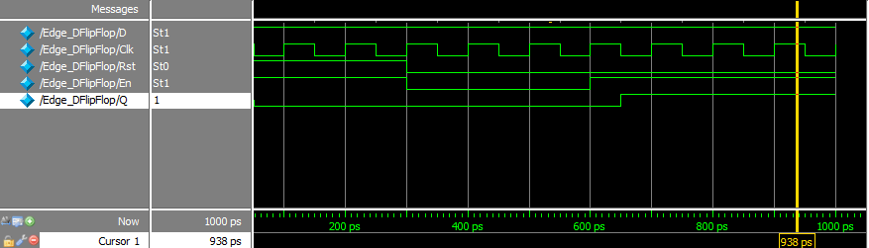
COUNTER DESIGN:
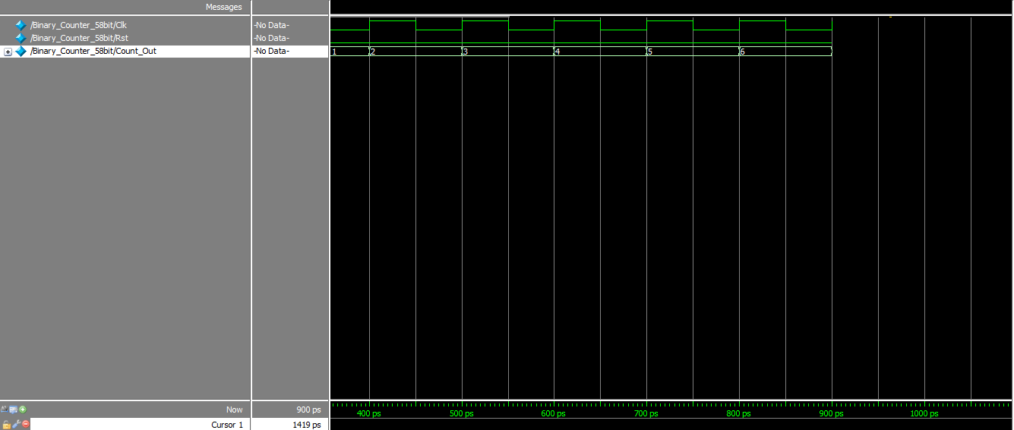
PROPOSED DESIGN:
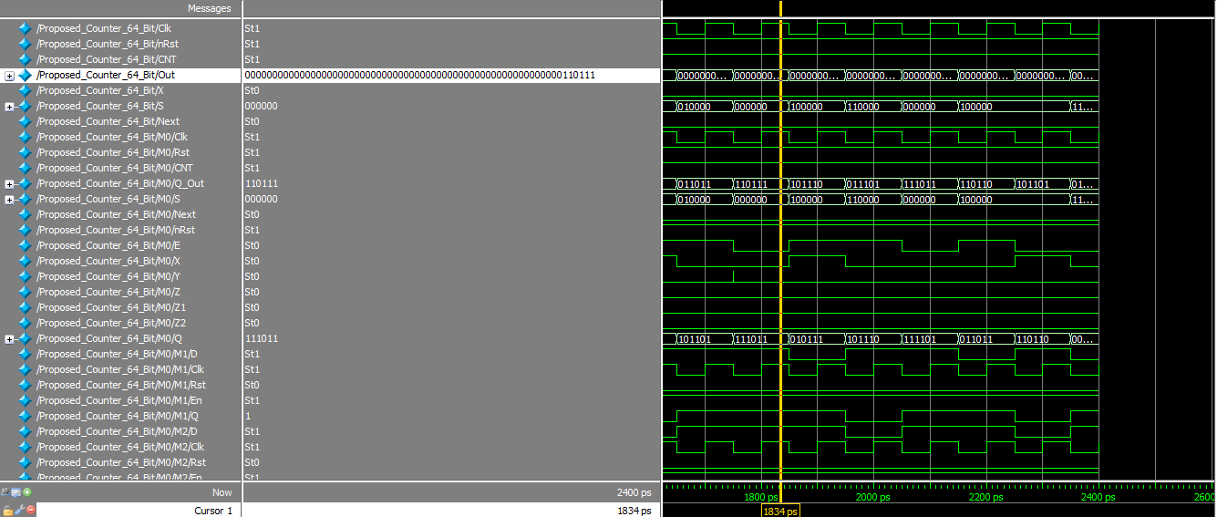
MODIFIED HYBRID DESIGN:
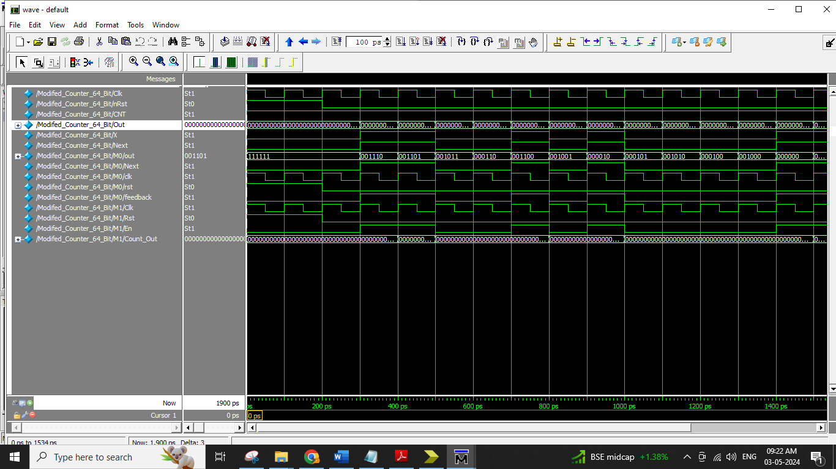
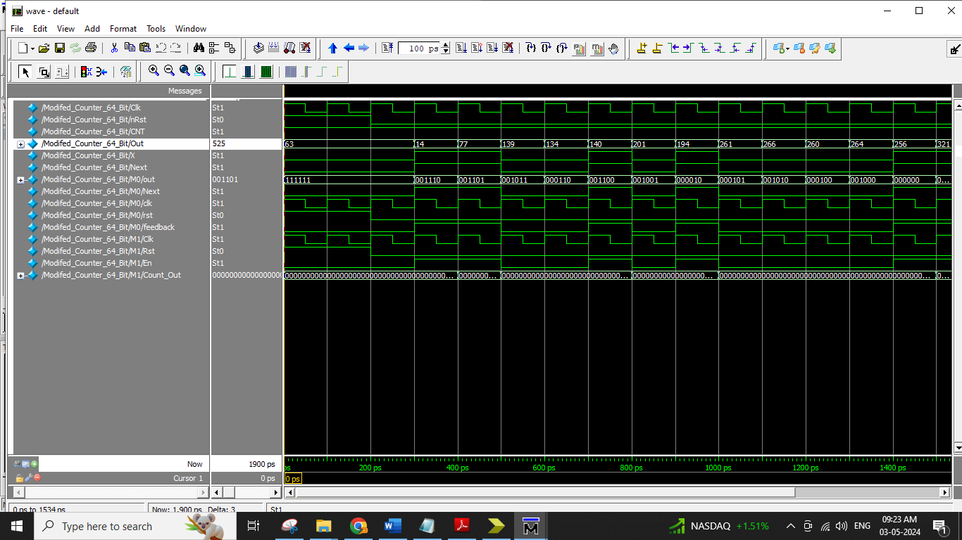

CHAPTER 6
SYNTHESIS RESULTS
6.1 DEVICE UTILIZATION SUMMARY
MODIFIED HYBRID DESIGN:
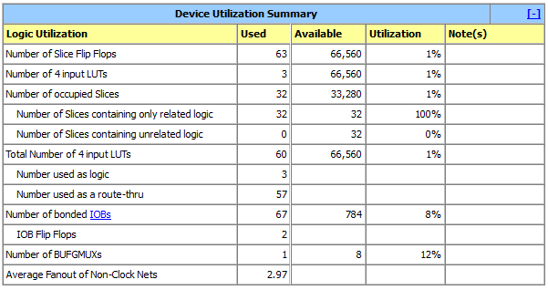

PROPOSED:
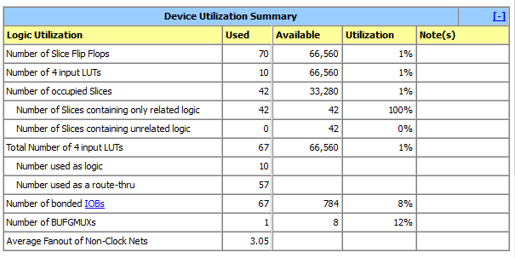
6.2 RTL SCHEMATIC
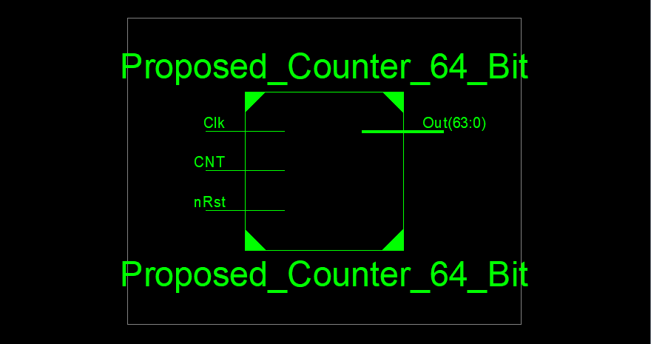
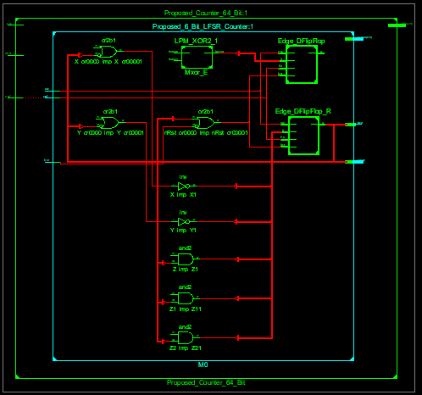
6.3 TECHNOLGY SCHEMATIC:
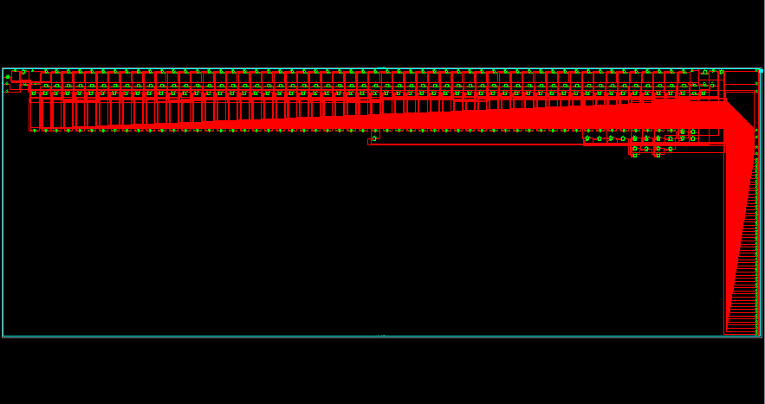
POWER:
Modified:
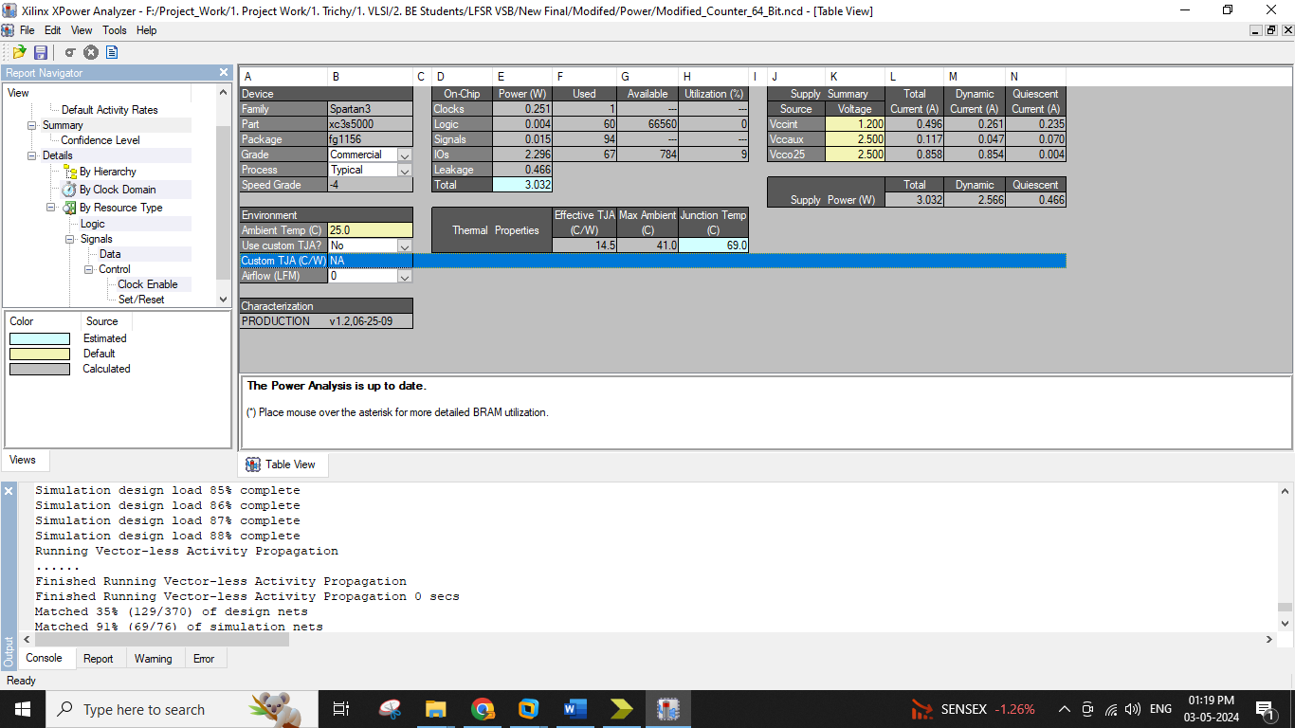
Proposed:
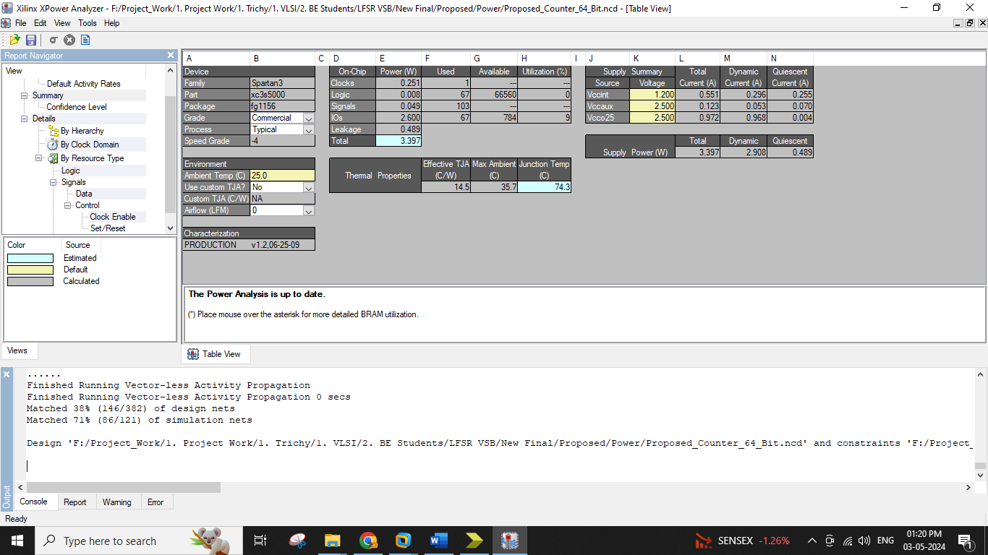

6.4 AREA POWER COMPARISON:
COMPARISON TABLE:
AREA AND DELAY COMMPARISON TABLE
Method Name | Area in Number of LUT |  |  | Delay |  |  | Power
Spartan 3 XC 3S 5000-4FG1156 | LUT | Slices | Flip Flop | Delay | Gate or Logic Delay | Path or Route Delay | mW
 |  |  |  |  |  |  | Total Power | Dynamic Power | Static Power
Base Paper Decompressor | 67 | 42 | 70 | 7.281ns | 6.364ns | 0.917ns | 3.397 | 2.908 | 0.489
Modified Compressive Sensing | 60 | 32 | 63 | 7.281ns | 6.364ns | 0.917ns | 3.032 | 2.566 | 0.466

AREA COMPARISON:

DELAY COMPARISON:

POWER COMPARISON:

CHAPTER 7
CONCLUSION AND REFERENCES
7.1 CONCLUSION:
This paper has proposed a high-speed counter architecture with a novel LFSR state extension method. To reduce the delay caused by detecting an LFSR state in a cycle, such a state is detected by considering only one bit in a cycle, which leads to a diagonal m-bit pattern that can be detected for m cycles. This unique diagonal pattern is detected with m F/Fs and ðm (m-1) gates. Based on a small-sized LFSR counter, the proposed counter is realized by taking a rescaled binary counter at the upper bit positions. In other words, the proposed 64-bit counter consists of two sub-counters: a 6-bit LFSR counter at the lower bit positions and a conventional 58-bit binary counter at the upper bit positions. The conventional prescaled counter requires a straight ring counter to ensure that both sub-counters count correctly, while the proposed LFSR counter enables the counting of the high-order sub-counter by detecting a specific state. The novel state extension method makes the proposed m-bit LFSR counter traverse 2m states as fast as the conventional LFSR, and thus the counting rate of the proposed counter is almost independent of the counter size.

7.2 REFERENCES:

REFERENCES
[1] D. Morrison, D. Delic, M. R. Yuce, and J.-M. Redoute, “Multistage linear feedback shift register counters with reduced decoding logic in 130-nm CMOS for large-scale array applications,” IEEE Trans. Very Large Scale Integration Syst., vol. 27, no. 1, pp. 103–115, Jan. 2019.
[2] D. Morrison, S. Kennedy, D. Delic, M. R. Yuce, and J.-M. Redoute, “A 64 64 spad flash lidar sensor using a triple integration timing technique with 1.95 mm depth resolution,” IEEE Sensors J., vol. 21, no. 10, pp. 11 361–11 373, Oct. 2020.
[3] T. K. Moon, Error Correction Coding: Mathematical Methods and Algorithms. Hoboken, NJ, USA: Wiley, 2020.
[4] F. Karimzadeh, N. Cao, B. Crafton, J. Romberg, and A. Raychowdhury, “A hardware-friendly approach towards sparse neural networks based on LFSR-generated pseudo-random sequences,” IEEE Trans. Circuits Syst. I Regular Papers, vol. 68, no. 2, pp. 751–764, Feb. 2020.
[5] A. Hu, D. Liu, K. Zhang, L. Liu, and X. Zou, “A 0.045- to 2.5-GHz frequency synthesizer with TDC-based AFC and phase switching multi-modulus divider,” IEEE Trans. Circuits Syst. I Regular Papers, vol. 67, no. 12, pp. 4470–4483, Dec. 2020
[6] Z. Shen et al., “A 12-GHz calibration-free all-digital PLL for FMCW signal generation with 78 MHz/ms chirp slope and high chirp linearity,” IEEE Trans. Circuits Syst. I Regular Papers, vol. 67, no. 12, pp. 4445–4456, Dec. 2020.
[7] F. Karimzadeh, N. Cao, B. Crafton, J. Romberg, and A. Raychowdhury, “Hardware-aware pruning of DNNs using LFSR-generated pseudorandom indices,” in Proc. IEEE Int. Symp. Circuits Syst. (ISCAS), Oct. 2020, pp. 1–5
[8] Z. Chen, Z. Chen, J. Lin, S. Liu, and W. Li, “Deep neural network acceleration based on low-rank approximated channel pruning,” IEEE Trans. Circuits Syst. I, Reg. Papers, vol. 67, no. 4, pp. 1232–1244, Apr. 2020
[9] P. Molchanov, A. Mallya, S. Tyree, I. Frosio, and J. Kautz, “Importance estimation for neural network pruning,” in Proc. IEEE/CVF Conf. Comput. Vis. Pattern Recognit. (CVPR), Jun. 2019, pp. 11264–11272.
[10] J. Kepner and R. Robinett, “RadiX-net: Structured sparse matrices for deep neural networks,” in Proc. IEEE Int. Parallel Distrib. Process. Symp. Workshops (IPDPSW), May 2019, pp. 268–274.

